Evaluation Strategy

Success Metrics
Three conventional pixel-based metrics, which are Accuracy, Intersection-over-Union (IoU), and F1-Score (Chen et al., 2018)will be used to assess the performance of the deep learning semantic segmentation models.
Such metrics are popular in the literature related to computer vision and remote sensing to determine the quality of segmentation and model reliability (Minaee et al., 2021).
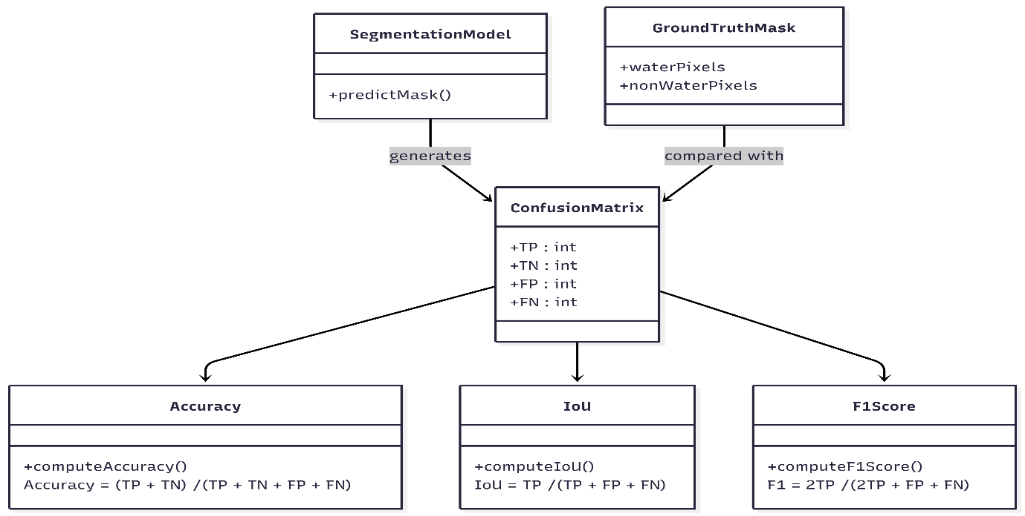
Figure 5 : Class diagram illustrating the relationship between segmentation outputs, confusion matrix components, and pixel-level evaluation metrics
Accuracy : It determines the percentage of the number of correctly identified pixels in the picture.
Accuracy = (TP + TN) / (TP + TN + FP + FN) ; TP is the number of true positive pixels (correctly predicted water), TN is the number of true negative pixels (correctly predicted non-water), FP is the number of false positive and FN is the number of false negative.
Intersection-over-Union (IoU) : IoU measures the intersection of the predicted and water mask and the ground-truth mask and works especially well with problems of class imbalance in segmentation.
IoU = TP / (TP + FP + FN)
F1-Score: It is the harmonic mean of Precision and Recall, is an unbiased measurement of segmentation performance. F1-Score = 2 × TP / (2 × TP + FP + FN)
All these metrics summarise the level of pixel accuracy and the overlap of spatial range with reference mask and predicted mask, allowing fair and reliable comparison of all models (Zhang et al., 2020).

Critical Evaluation
Technical analysis To be used in technical evaluation will be based on comparative research of the segmentation performance of U-Net, FCN, DeepLabV3-Lite and Attention-residual U-Net to perform the segmentation activity with the same (Ma et al., 2021) experimental conditions. Accuracy, IoU, and F1-Score are going to be used to find quantitative results that will be supplemented by qualitative visual inspection of segmentation results to reveal strengths, weaknesses, and failure cases across various models.
Besides the technical performance, the social and ethical implication of the application shall be critically considered. Possible problems, including bias in datasets, lack of geographic generalisation, and implications of errors of segmentation (Donchyts et al., 2021) in real life situations, especially flood management and water resource management will be addressed. The detection of water bodies can be inaccurate, resulting in poor environmental evaluation or sluggish response to disasters, which is why accurate and transparent AI systems in socially sensitive areas can be essential (Pekel et al., 2019).

Project Management & GitHub Integration

The GitHub Rule
Any project activity such as code development, experimentation, documentation and planning will be completely documented by the use of GitHub. The incremental approach will include regular commits that will be made by team members during the course of the project, which will be meaningful and regular. To make sure that there will be transparency, reproducibility and equal evaluation of the contributions made by individuals, large, late code dumps will be avoided.

Weekly Monitoring
The main tool to be employed in the weekly monitoring and task management is the GitHub Project Board. GitHub issues will be used to create project tasks and placed in workflow columns (To Do, In Progress, Review, and Done). All issues will be clearly documented, allocated to a team member and associated with commits. The progress will be checked weekly to make sure that there is continuous involvement and the uniform distribution of workload among the team.

Roles and Responsibilities
Team Member | Role | Responsibilities
BinduBhargavi Madduluri | Project Manager & GitHub Coordinator | Oversees overall project planning and scheduling, manages the GitHub repository and Project Board, and ensures regular commits and task updates are maintained throughout the project.
Harshita Kotla | Data Engineer | Responsible for dataset acquisition, data preprocessing, cleaning, and preparation of training, validation, and test sets to ensure data consistency and reproducibility.
Mohammed Amer | Model Developer | Implements and trains deep learning semantic segmentation models, manages model configurations, and saves trained weights for inference and evaluation.
Venkata Chandu Kongani | Evaluation & Documentation Lead | Conducts quantitative and qualitative performance evaluation, prepares result tables and visualisations, and contributes to technical analysis and report writing.
Salva Muskan | Documentation & Presentation Lead | Responsible for structuring and proofreading the report, preparing the README file, and coordinating the live demonstration and project pitch.
Table 2 : Above table represents the roles and responsibilities of every member in the team

Dataset Suitability and Feasibility
The project makes use of the Satellite Images of Water Bodies dataset (Escobar, 2020) which is a collection of Sentinel-2 RGB satellite images that have binary water masks. The dataset is openly released and can be used under academic and research purposes within Kaggle standard terms of data use, which makes it appropriate in the university coursework and research projects. It is well trained and evaluated on models of semantic segmentation based on deep learning, particularly due to its clear labelling, intermediate size, and organised structure.
This data set has been extensively used in various scholarly researches, student projects and real-world computer vision experiments and it has proved to be relevant and reliable in performing water body segmentation tasks. The presence of paired images and ground-truth masks makes it possible to use supervised learning and compare and contrast different models with fair results. Moreover, the manageable scale of the dataset implies that the model training and inference can be computational and within the time and resource limits of the project and achieve the successful implementation and assessment of the suggested approach.

Gantt Chart

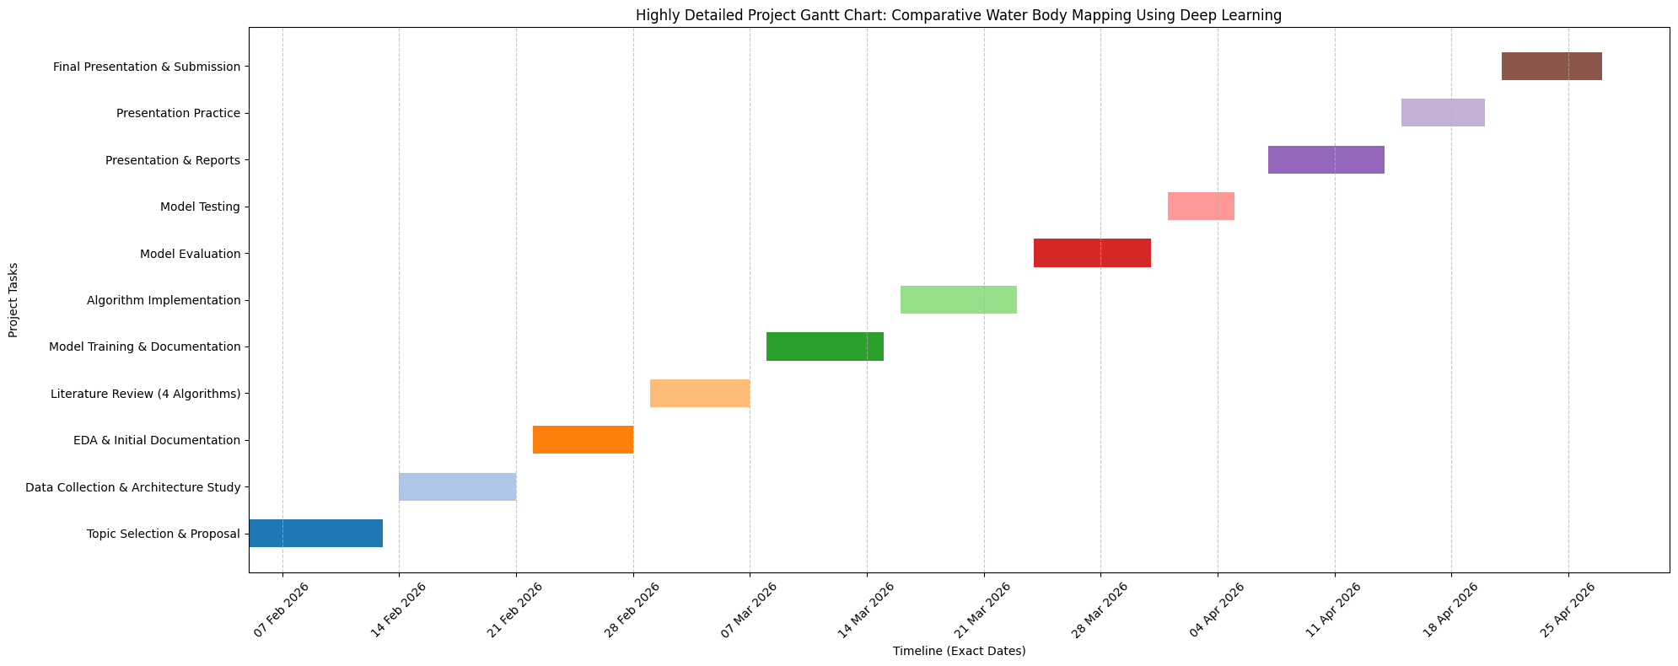
Figure 6 : Detailed Gantt Chart that will be followed during entire Project

